WEEC Pilot Study
Group 02
Ahtera Dixon, Chris Mhyren, Dominique Jackson, Nathan Tse, Jeff Sprotberry

Table of Contents
Executive Summary 3
Introduction 4
Methodology 5
Methodology 5
Research Methodology 5
Data Collection Method 5
Population for the Study 5
Sampling Methodology 6
Development of the Survey Instrument 6
Administration of the Survey Instrument 6
Data Analysis Procedure 6
Data Analysis 7
Summary of Data 7
Statement of Finding 12
What is the age and gender of the listening audience? 12
What are the music and programming preference of the listening audience? 24
Conclusion 41
Appendix 42
Survey Instrument 42
Open Responses Data 47
Response Rates 47

Executive Summary
WEEC has been serving the Springfield, OH area on the FM band since December 1961. It is a Religious / Christian Institution that focuses on providing “Radio You Can Believe In.” The contact we have at WEEC believes that the the station’s demographic is steadily aging (75+) and passing away. Due to this morbid circumstance, the station is looking to gather information on the attitude, lifestyle, and demographics of their audience, which would allow them to tailor their programming to target a more desirable audience. (55+)

To address the main problem, we came up with two research questions that would target attitudes, demographics, and lifestyle:
- What is the age and gender of the listening audience?
- What are the music and programming preference of the listening audience?

From the data analysis, the client can breathe a sigh of relief - a large portion of their listening audience does fall into the desired age range of 55-74 (60% of the surveyed audience). However, it should be noted that female listeners currently dominate the listening audience of the station. While WEEC can and should cater to women listeners, the station should also make plans to draw in more male listeners. Surprisingly enough, the programming of highest listener preference are “preaching and teaching” and news related programming, so WEEC should either maintain or improve upon those two programming choices.

Following these, Music came in a close third. The most liked music genre is “soft contemporary” (with an average score of 4.25/5, 5 being “strongly like”), while the most disliked is Christian Folk.

If you break down music preferences to the listening ages of the audience, Soft Contemporary is rated first, with Christian pop and worship a close second and third.

Overall, it seems like WEEC is meeting its desired age demographic with current programming choices. Keep in mind, the data contained within this report is not representative of a sample that may be extrapolated to the population – we used a convenience sample of WEEC donors with email addresses, so all data within should be viewed as a starting point for further, full-fledged research.

Introduction
WEEC has been serving the Springfield, OH area on the FM band since December 1961. It is a Religious/Christian station that focuses on providing “Radio You Can Believe In.” As a non-profit corporation by design, WEEC has shifted from a commercial station into a radio station completely supported by free-will contributions. An annual SHARATHON is held each March, to raise faith promises for next year’s budget. However, the statement management has informed us that they believe that their demographic is steadily aging (75+) and passing away. Due to this information and the fact that WEEC runs on free-will contributions, it has stated that the station’s funding is slowly on the decline. Therefore, WEEC decided to look into gathering statistical information on the demographical specifics and attitudinal dimensions of their audience, which will allow them to tailor programming to specifically target a slightly younger age group in terms of listening audience (55+). Through these data requirements, we will take into account who is listening and how they feel about the station’s music choices.

Of course, WEEC’s problem is of dire importance as it pertains to the livelihood of the station, especially in these economically unstable times. If the management’s assumption about the age of the audience is correct, then the station is likely to face a corresponding decline in the amount of money it can raise to remain on the air. In financial terms, it would mean that the station would have to turn back to using their commercial frequency and partnerships with various organizations to keep the station running, which is the least favorable outcome for the client. The station prides itself in 80% programming and 20% Public Services and news, no doubt they would prefer to retain as is. While WEEC has anecdotal evidence that leads them to the conclusion that their current audience is of 75 years or older, they would like to have empirical evidence that allows them to access their current audience and make the necessary changes.

Many of our secondary research scans showed many people decided to focus their study on the listening and giving habits of the radio listeners. There have been written works that focus on the use of mobile technology in the radio industry. While this could be useful information, it probably is not as relevant for the direction that WEEC is heading, it would be a viable option of looking into technology related to internet and smart media. Devices such as smartphones are becoming common everyday objects and could very well be used to connect to the target demographic through a younger age group. Of a more important note, there’s other evidence that covers how the radio station is catering to their audience in order to maintain or increase funding. This is of special importance to WEEC as they are indeed looking for the necessary information that will allow them to cater to their target audience of 55 and up.

In order to meet the needs of the client, we need to research the demographics and the attitude of the audience. We will attempt to address the client’s needs with the following questions:
- Who is the listening audience?
- What are the music / programming preferences of the audience?

Methodology

Methodology
In order to continue working on the client’s needs, we have to decide on the best selection of research methodology by looking through the advantages and disadvantages of each method. When looking at what the client needed, we came to the conclusion that a Descriptive Survey would be the best option. The client needed demographic information, behavior information, as well as attitudes and opinions about the people who were listening to WEEC. These were all categories that descriptive surveys could cover because by nature descriptive surveys attempt to capture and document current conditions or attitudes.

Research Methodology
Due to the nature of the client’s needs and budget limitations,, we opted to do a non-probability sample survey through the use of a convenience sample; a core group of WEEC’s listeners per se so that we can at least give WEEC a good look at what the core listeners are interested in listening and the age and gender of that group. Of course, since this is not a full-blown market survey, the results cannot be generalized to the entirety of the listening audience of WEEC. Therefore, this can only be viewed as a pilot study which provides WEEC with some initial information of its core listeners. The information can also be used as a model, should the station decides to extend the scope of the research to all of its donors or a true probability sample of its entire audience.

Data Collection Method
Since WEEC gave us a list of 470 donors with emails, the most natural conclusion was to resort to the use of internet survey or email survey. While both are effective in their own rights, we opted to use internet survey, which is one of the fastest and most efficient ways to achieve data collection. One of the pros of conducting a survey through email is the cost-effectiveness, along with the ability of the participants to take the survey on their own - allowing them a greater amount to time to think about their responses when compared to other types of surveys. However, there are also downsides to the internet survey approach. Due to email filters, our attempts to reach the donors could be considered as spam and be filtered out. Also due to WEEC’s target age (55+), we also have to be concerned about the technological inclinations of some of the older folks. On top of these cons, there is also the obvious trend of massive response rates on the first few days then the sharp drop off rates. In order to defeat that trend, we contacted the donors four times to try to increase the response rates.

Population for the Study
Given WEEC’s needs, the survey needed to be conducted among the WEEC donors. The population of population definition is as follows: People who have donated to WEEC who live within the western / west-central part of Ohio within the past five years who have provided email addresses to the station. It should be noted that this is a pilot survey or preliminary study for the station and hence it will provide the station with some sense of who their current listeners are by targeting their core audience. However, due to the nature of the study, and not being able to conduct a general market survey using a probability sample, it will be impossible to generalize the station’s entire audience from the results of this survey. The information gleaned from this survey will provide information regarding the core audience as well as providing a model for future research should the station decide to take the next step and expand to their entire mailing list or to a general market survey.

Sampling Methodology
In order to keep to cost down for the station, we did not do a full-market study with a probability sample. Instead, the decision was made to limit this study to a convenience sample consisting of donors to the station who have provided email addresses. Since a non-probability sample was used, this study should only be considered a pilot study and hence can only draw basic conclusions about the core listeners of the station and should not be generalized towards the entire listening audience of the station. In the end, we’ve decided to conduct a census of the 400 or so email addresses that we have obtained from WEEC.

Development of the Survey Instrument
In order to find out the attitudes, demographics, and lifestyle of the donors, a survey instrument is required to gauge where the listeners are at. Our research group created an initial draft of the survey instrument asking about music, listening hours, medium used to listen to the radio and so on. As time goes on, we revised and refined the survey instrument and sent it to WEEC for any additional feedback. We also prepped the sruvey instrument for a trial run with focus groups, which are used to give the survey instruments a trials run before it is sent out to the wild. Two focus groups consisting of ten people each were used to conduct our initial test surveys. The focus groups were not given any hints of what the survey is about ahead of time and completed the survey, then were asked about what they think of the survey and then we systematically went through every single question in the survey to ask about any issues that the focus groups ran into while doing the survey. The feedback from the client as well as the focus groups (full detail in appendix) were used to craft the final revision of the survey instrument. The final revision was then sent off to the Information Technology staff, who coded the instrument for an online survey.

Administration of the Survey Instrument
This is done in two parts. The first part was to send out a postcard to our 400 or so donors to give them a heads up about a link to a survey will be coming to to their emails shortly. Typically, self-administered instruments are pretty low and to combat that low-response rate, we tried to email our contacts four times. Our first attempt was April 1st, which garnered a decent amount of response rates the first couple of days then steadily dropped off. We tried contacting the donors again on 2nd, the 8th, and the 12th. All of those days saw an increase in response, then it steadily dropped off. The final count of the respondents--the acceptance rate--is 171, which is roughly 36% of the 470 total donors we tried to contact. To look at the breakdown of the response in detail, please look at the appendix.

Data Analysis Procedure
In order to compile a comprehensive analysis of the data, illustrative representations of the information garnered via the questionnaire were needed. The charts created during the data collection procedure provided the necessary information. Upon review of the entire selection of graphs and charts, we were able to extract observations that could then be implemented in the resolution of the client’s need(s).

Data Analysis

Summary of Data
The initial 4 inquires presented on the survey collected data concerning prevailing time-related trends in listening. The data shows the respondents’ preferences in listening to WEEC, as it pertains to time periods, time lengths and frequency.

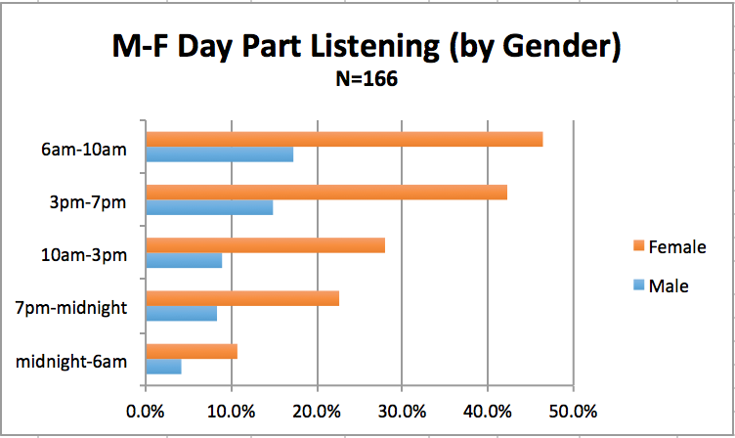

As indicated here, Monday through Friday from 6am to 10pm is the most popular time range for both male (17.3%) and female (46.4%) listeners. 3pm-7pm is a close second, with males at 14.9% and females at 42.3%. There may be a correlation between these statistics and the fact that, according to the chart below, listeners most commonly (38.1%) tuned in to WEEC over the course of two dayparts.

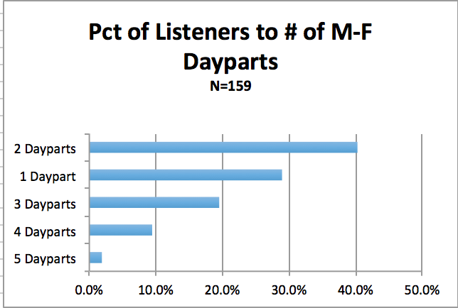

The statistics for time spent listening are very eye-opening.

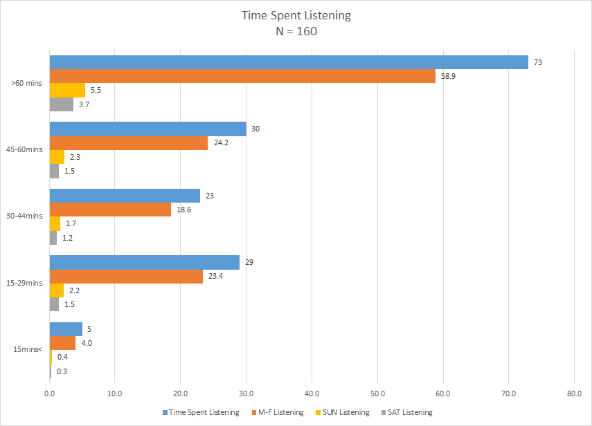

The data on the above graph show that, in terms of overall time spent listening, 60+ minutes is easily the most popular option among respondents, receiving more than double the responses 45-60 minutes received. Also, in every timespan category, M-F listening far outranks Sun. listening and Sat. listening.

The series of graphs below show the same information, but in reference to the respondents’ habits on Saturdays and Sundays.

Saturdays

Sundays

The 5th item, the data from which is represented below, asks about listening location.
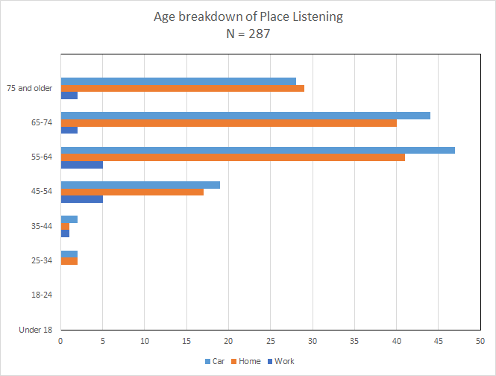
It is readily apparent that listeners of all ages except those 75 and older strongly prefer to listen to WEEC in their cars (39.0%), and even among those respondent’s 75+, the car was the second most popular listening location.

The next 3 queries on the questionnaire ask for feedback on programming preferences: preferred programming type, types of “preaching and teaching” programs and preferred music genres. Specifically for music genres, choir music received an average score of 4.02, southern gospel received a 4.09, soft contemporary received a 4.25, worship music received a 4.00, Christian pop received a 4.05, Gospel received a 3.82 and Christian folk received a 3.65; soft contemporary is clearly the fan favorite in this category. The data also show that “preaching and teaching” is the most popular type of broadcast programming, receiving the highest rating of “strongly like” among the types of broadcasts, as well as having the most supportive responses in the Open Responses section.

The final 2 questions on the survey requested further demographic information, the age and gender of the respondent, neither of which have very much bearing on the actual answers given by themselves. They do, however, provide insight into who made up the sample used to obtain the data.

Statement of Finding

What is the age and gender of the listening audience?

After analyzing the data it was clear that certain demographics were more inclined to listen to WEEC. Age certainly plays a role in who is listening to the station as can be seen in the graph directly below.

Clearly, the data suggests that the majority of WEEC’s listeners fall between the ages of 55-74. These two groups alone make up over 60% of the respondents. Fortunately, these age groups are already the desired target audience for the station. This can be broken down further to see which age groups listen at each part of the day and night. The following graphs will show how each age group listens throughout the day and night.

Of all the periods of time analyzed throughout the day, the 6am-10am block had the highest percentage of listeners. This time period also complies to the established trend of listenership among age groups. 55-64 and 65-74 are the two leaders in this group, as they are for almost all dayparts. These results are even further exaggerated in the next graph.

While 10am-3pm does not have as many listeners as the 6am-10am block, it is still an important part of the day for WEEC. However, the age groups 55-64 and 65-74 pull much further away from other age groups such as 75+ and 45-54. This would be interesting to research why this happens, perhaps it comes down to programming, but our research did not cover this question. The next graph reports similar results with 55-64 and 65-74 leading the pack again.

From 3pm-7pm the trends continue. Other than the 6am-10am block, this is the second most important daypart for WEEC. Trends continue here as well, so there is nothing new to note. The following graph highlighting the 7pm-Midnight block is almost identical as well.

The same trends continue in this graph as well. However the following graph, covering Midnight-6am, has strikingly different results.

This time period is the least important block for WEEC in terms of total listenership. However, it is interesting to note that the percentage of 65-74 year olds listening to the station drops by a major amount. The 75+ age group inexplicably takes over in second place. Fortunately this is block of time has the smallest number of listeners, so WEEC should keep that in mind. The next graph depicts the amount of listeners who do not listen during the weekdays.

This chart shows most significantly that there is a fairly large amount of listeners among the target audience who only listen on the weekends. The next series of graphs will specifically look at the percentages of age groups who listen on Saturdays.

As with the weekdays, on Saturdays the target audience dominates the morning again. These trends essentially mirror all the weekdays blocks. Below is the next time block’s graph.

This graph shows change in its results. For some reason, the percentage of 45-54 year olds jumps above the percentage of the 75+ age group. Further research would be required to understand this.

As with the weekday results, the percentage of 65-74 year olds inexplicably drops significantly in the Midnight-6am daypart. Perhaps this could be contributed to simply the specific respondents, or maybe it is something to do with the programming. Either way, more research needs to be done to give a definitive answer.

This graph shows that the percentage of people who do not listen on Saturdays increases somewhat when compared to weekdays. Next Sunday listening will be shown.

Like the other days of the week, the 6am-10am is the most important part of the day for WEEC. The target audience is hit again, which is encouraging.

The same trend emerges during this block, in a very similar fashion to the other days.

Overall, Sunday seems to be the weakest day for WEEC in terms of total listenership. The trends are the same, but less total listeners tune in. Perhaps a change of programming could increase listenership on this day.

The data analysis also provided definitive results about gender, which can be seen in the graph below.

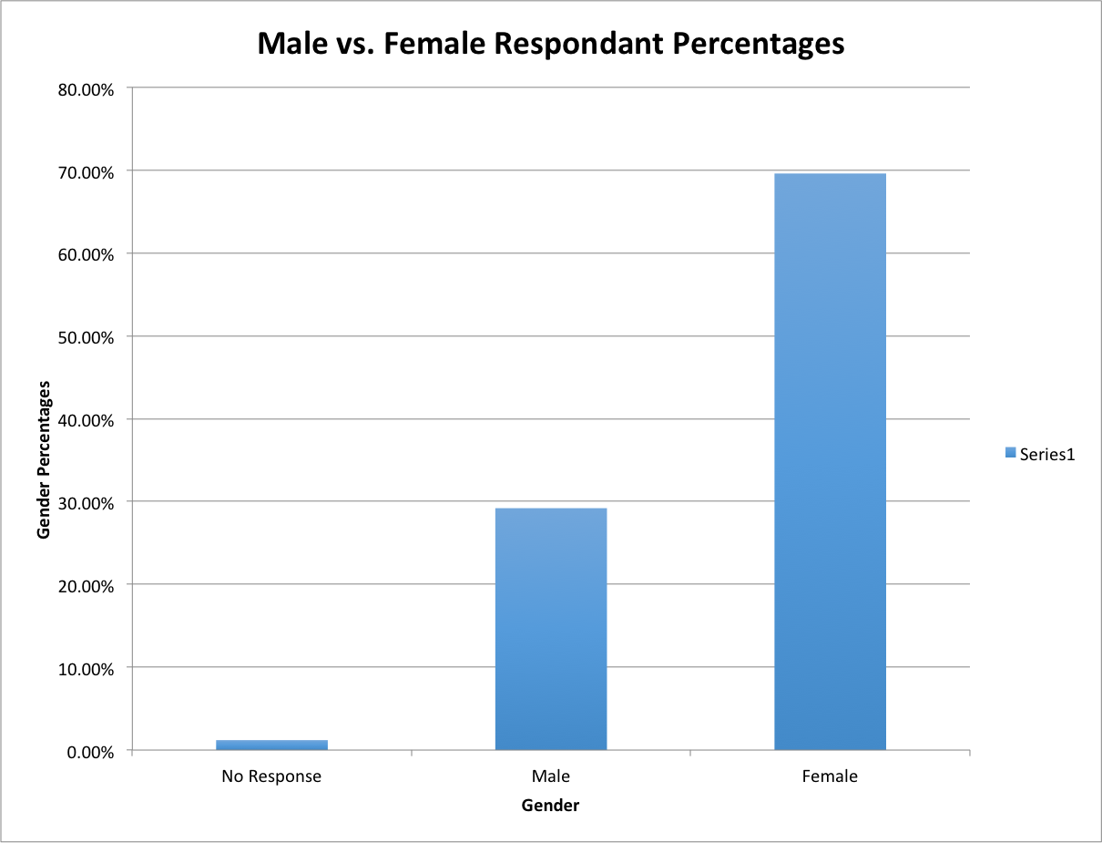
N=170

The data here shows female listenership as more than double the percentage of males. This would mean that currently WEEC’s main audience is females aged 55-74. No matter the time of day these results remain the same, as the following graphs will illustrate.

No matter the time, or the day, female listeners dominate the males. There is not a single time period where men have even half as many listeners. Therefore WEEC should make sure to cater to these women, specifically aged 55-74, as they are the main audience.

What are the music and programming preference of the listening audience?

All programming on WEEC aggregated a positive overall score when the results were tabulated. However some received responses which were more positive than others. Respondents were asked to rate the programming on a scale from 1-5 with 1 being “strongly dislike” through 5, which was “strongly like”. The following graph will show the trends that developed.

This shows that when analyzed closely, Preaching and Teaching programming rises to the top as the most popular programming. Surprisingly, while still positive, music is the second lowest rated programming. The next graphs will go into more depth on the specifics of the music programming.

The results for music were mostly positive for WEEC. As the following graph will show, a large percentage of the listeners have a positive opinion of the music.

As can be seen above over 50% of the respondents “strongly like” the music WEEC plays. That combined with those who only “like” the music shows that 80% of the respondents have a positive opinion of the music. The following graph will break down these opinion further into the specific age groups.

These graphs have very similar results to the overall opinions of the music. The 65-74 group overall has the strongest positive reaction to the music with almost 90% of respondents with a postive response. When broken down by genders however, the results perhaps shed light on why more females listen to WEEC.

This graph shows that while most of the respondents had a positive opinion of the music, the men were much more likely to have a negative opinion compared to the women. In fact almost 10% of the men put down “strongly dislike”, compared to only about 1% for the women.

Next favorite genres for each age group will be given. On the below charts, 5=strongly like and 1=strongly dislike.

The important categories to look at here are the 55-74 averages. These are the two groups that fall within the target audience for WEEC. It can be seen that the most popular genre between them would be Soft Contemporary. On the other end of the spectrum is Christian folk. The target audience does not seem to like this genre and perhaps phasing it out would be wise.

Next, opinions towards Preaching and Teaching programming will be analyzed.

Of all the programming that WEEC offers, this is its most popular.

All age groups have positive responses to this programming, but the 45-54 age group is by far the highest.

These charts show very positive results for Preaching and Teaching for both genders.

Next children’s programming results will be shown.

Here it can be seen that the 75+ age group is much less enthusiastic about children’s programming when compared to the other groups. Not only that, but the 45-54 age group enjoys this programming the most. While this is not the target audience, the other age groups do not have bad responses either, so this does not seem to be too disheartening.

This is the most important chart for children’s programming; it shows that male’s specifically tend to gravitate toward the neutral position. This could be another indication of why male support for the station is so much lower than female support. The next programming that will be analyzed will be Current Events.

While still mostly positive results are presented, males definitely tend to have more negative views than females in general for this programming. Next, results for Local Info will be shown. This programming had some of the most neutral results of any of the programming.

Compared to other programming, Local info had a very high percentage of neutral opinions. Not only that, but the Strongly Like option is down as well. We still see positive results, but this programming is certainly not as appreciated as some of the other programs.

Strangely, the 45-54 age group has the most positive opinion of this programming with 50% of their respondents reporting that they Strongly Like it.

Neutral jumps out as unusually high when broken down by gender as well. It is not only the men this time who are putting this option. For this programming, even the women, who tend to have more positive results throughout the entire survey, have more neutral responses than the men.

The following graphs will look at the News programming results.

Just like the Local Info programming, the 45-54 age group likes the News programming the most. This is not the target audience for WEEC, so more research should be done to see what could be done to make this programming more applicable to their target age groups.

Still very positive results for WEEC, females in particular have very positive opinions of the News programming.

The final data to be analyzed will be the Talk Show results.

The Talk Show programming in particular seems to hit the 65-74 age group quite well. This age group has much more favorable results than any other group. Fortunately this is part of WEEC’s target audience, so it does not seem as though changes will need to be made to this programming.

Again, women tend to have much more positive opinions of the programming than the men.

Conclusion
In conclusion, the research thoroughly and adequately addresses the research questions. There are some obvious trends that WEEC has to look out for, such as the high percentage of women listeners and the musical taste of the target audience, but it seems that the station is doing well in selecting appropriate programming for their target demographic. More than mere numbers and statistics, these are real-life facts and they can be employed to alter business choices and practices to the end of running the business more effectively. Suffice to say, this data feedback provided by donors should help WEEC immensely as they move forward. If they should decide to conduct a full-blown market survey, they will have a decent model to work off of.
Given that the survey was only dealt to a sample of listeners, the results should not be taken as set-in-stone laws of the land, as they are only the reflections of a convenience sample. The data presented here is intended to show the feelings of a mini-WEEC universe in an effort to present the client with an avenue for re-evaluation and, if necessary, correction of current programming

Appendix

Survey Instrument
Q2. To start out, think about your Monday through Friday weekday listening. What hours of the day during weekdays do you typically listen to WEEC? (Frequency = 168)
- Q2_1: 6 am-10 am (N=107, 63.7%)
- Q2_2: 10 am-3 pm (N=62, 36.9%)
- Q2_3: 3 pm-7 pm (N=96, 57.1%)
- Q2_4: 7 pm-Midnight (N=52, 31%)
- Q2_5: Midnight to 6 am (N=25, 14.9%)
- Q2_6: I don’t listen to WEEC on weekdays (N=9, 5.4%)

Q3. Let’s move to the weekend. What hours of the day during Saturdays do you typically listen to WEEC? (Check all time periods that apply) [Multiple Choice (Multi Selection)] (N=168)
- Q3_1: 6 am-10 am (N=67, 39.9%)
- Q3_2: 10 am-3 pm (N=61, 36.3%)
- Q3_3: 3 pm-7 pm (N=45, 26.8%)
- Q3_4: 7 pm-Midnight (N=34, 20.2%)
- Q3_5: Midnight to 6 am (N=18, 10.7%)
- Q3_6: I don’t listen to WEEC on Saturdays (N=42, 25%)

Q4. Now on to Sunday. What hours of the day during Sundays do you typically listen to WEEC? (Check all that apply) [Multiple Choice (Multi Selection)] (N=168)
- Q4_1: 6 am-10 am (N=88, 52.4%)
- Q4_2: 10 am-3 pm (N=39, 23.2%)
- Q4_3: 3 pm-7 pm (N=30, 17.9%)
- Q4_4: 7 pm-Midnight (N=34, 20.2%)
- Q4_5: Midnight to 6 am (N=19, 11.3%)
- Q4_6: I don’t listen to WEEC on Saturdays (N=40, 23.8%)

Q5. Where are you when you listen to WEEC? (Check all that apply) [Multiple Choice (Multi Selection) with Other] (N=171)
- Q5_1: Car (N=142, 83%)
- Q5_2: Home (N=131, 76.6%)
- Q5_3: Work (N=14, 8.2%)

Q7. Within the past seven days, which day of the week did you most recently listen to WEEC? [Multiple Choice (Single Selection)] (N=170)
- 1 » Monday (N=23, 13.5%)
- 2 » Tuesday (N=34, 20%)
- 3 » Wednesday (N=34, 20%)
- 4 » Thursday (N=19, 11.2%)
- 5 » Friday (N=19, 11.2%)
- 6 » Saturday (N=8, 4.7%)
- 7 » Sunday (N=12, 7.1%)
- 8 » I did not listen to WEEC within the past seven days (N=21, 12.4%)

Q8. How long would you say you listened to WEEC on the most recent day you listened? [Multiple Choice (Single Selection)] (N=171)
- 1 » Less than 15 minutes (N=5, 3%)
- 2 » 15-29 minutes (N=29, 17%)
- 3 » 30-44 minutes (N=23, 13.5%)
- 4 » 45-60 minutes (N=30, 17.5%)
- 5 » More than 60 minutes (73, 42.7%)
- 6 » I did not listen to WEEC within the past seven days (11, 6.4%)

Q10. For each program category, pick the point on the scale that best describes your attitude towards it.

Q10_1: Music (N=161)
- 5 - Strongly Dislike (N=6, 3.7%)
- 4 - Dislike (N=12, 7.5%)
- 3 - Neither Dislike nor Like (N=13, 8.1%)
- 2 – Like (N=44, 27.3%)
- 1 - Strongly Like (N=84, 52.2%)
- 0 - Not Familiar (N=2, 1.2%)

Q10_2: Preaching and Teaching Programming (Truth For Life, In Touch, Running to Win) (N=166)
- 5 - Strongly Dislike (N=7, 4.2%)
- 4 - Dislike (N=4, 2.4%)
- 3 - Neither Dislike nor Like (N=6, 3.6%)
- 2 – Like (N=47, 28.3%)
- 1 - Strongly Like (N=98, 59%)
- 0 - Not Familiar (N=4, 2.4%)

Q10_3: Children’s Programming (Adventures in Odyssey, Lamplighter Theatre, The Pond) (N=163)
- 5 - Strongly Dislike (N=5, 3.1%)
- 4 - Dislike (N=3, 1.8%)
- 3 - Neither Dislike nor Like (N=25, 15.3%)
- 2 – Like (N=37, 22.7%)
- 1 - Strongly Like (N=74, 45.4%)
- 0 - Not Familiar (N=19, 11.7%)

Q10_4: Current Events and Contemporary Issues (Focus on the Family, Viewpoint) (N=167)
- 5 - Strongly Dislike (N=6, 3.6%)
- 4 - Dislike (N=2, 1.2%)
- 3 - Neither Dislike nor Like (N=19, 11.4%)
- 2 – Like (N=55, 32.9%)
- 1 - Strongly Like (N=80, 47.9%)
- 0 - Not Familiar (N=5, 3%)

Q10_5: Local Information (Community Clipboard) (N=167)
- 5 - Strongly Dislike (N=3, 1.8%)
- 4 - Dislike (N=7, 4.2%)
- 3 - Neither Dislike nor Like (N=35, 21%)
- 2 – Like (N=54, 32.3%)
- 1 - Strongly Like (N=57, 34.1%)
- 0 - Not Familiar (N=11, 6.6%)

Q10_6: News (WEEC News, Mission Network News) (N=167)
- 5 - Strongly Dislike (N=6, 3.6%)
- 4 - Dislike (N=3, 1.8%)
- 3 - Neither Dislike nor Like (N=20, 12%)
- 2 – Like (N=55, 33%)
- 1 - Strongly Like (N=79, 47.3%)
- 0 - Not Familiar (N=4, 2.4%)

Q10_7: Talk show (Midday Connection, In the Market, Building Relationships) (N=165)
- 5 - Strongly Dislike (N=6, 3.6%)
- 4 - Dislike (N=5, 3%)
- 3 - Neither Dislike nor Like (N=24, 14.6%)
- 2 – Like (N=35, 21.2%)
- 1 - Strongly Like (N=81, 49.1%)
- 0 - Not Familiar (N=14, 8.5%)

Q11. If there is a particular program or category of programs you like that you don’t think fits into one of the categories provided, then tell us what it is: [Text Box (Multi)]

Q13. For each music category, pick the point on the scale that best describes your attitude towards it.

Q13_1: Choir (artists such as Brooklyn Tabernacle, The Preston Wood Choir) (N=169)
- 5 - Strongly Dislike (N=8, 4.7%)
- 4 - Dislike (N=5, 3%)
- 3 - Neither Dislike nor Like (N=30, 17.8%)
- 2 – Like (N=54, 32%)
- 1 - Strongly Like (N=67, 39.6%)
- 0 - Not Familiar (N=5, 3%)

Q13_2: Southern Gospel (artists such as Talley Trio, Crabb Family, Legacy 5, Gold City) (N=167)
- 5 - Strongly Dislike (N=10, 6%)
- 4 - Dislike (N=8, 4.8%)
- 3 - Neither Dislike nor Like (N=20, 12%)
- 2 – Like (N=41, 24.6%)
- 1 - Strongly Like (N=81, 48.5%)
- 0 - Not Familiar (N=7, 4.2%)

Q13_3: Soft Contemporary (artists such as Chris Tomlin, Sarah Groves, Shannon Wexelberg, Phillips, Craig & Dean, Michael W. Smith, Point of Grace) (N=168)
- 5 - Strongly Dislike (N=5, 3%)
- 4 - Dislike (N=7, 4.2%)
- 3 - Neither Dislike nor Like (N=14, 8.3%)
- 2 – Like (N=54, 32.1%)
- 1 - Strongly Like (N=83, 49.4%)
- 0 - Not Familiar (N=5, 3%)

Q13_4: Worship (artists such as Charlie Hall, Hillsong United, Elevation Worship, Kristian Stanfill, Chris Tomlin) (N=164)
- 5 - Strongly Dislike (N=4, 2.4%)
- 4 - Dislike (N=9, 5.5%)
- 3 - Neither Dislike nor Like (N=23, 14%)
- 2 – Like (N=53, 32.3%)
- 1 - Strongly Like (N=53, 32.3%)
- 0 - Not Familiar (N=22, 13.4%)

Q13_5: Christian Pop (artists such as Steven Curtis Chapman, Aaron Shust, Amy Grant, Building 429, Casting Crowns, TobyMac, Jason Gray) (N=166)
- 5 - Strongly Dislike (N=7, 4.2%)
- 4 - Dislike (N=12, 7.2%)
- 3 - Neither Dislike nor Like (N=18, 10.8%)
- 2 – Like (N=54, 32.5%)
- 1 - Strongly Like (N=71, 42.8%)
- 0 - Not Familiar (N=4, 2.4%)

Q13_6: Gospel (artists such as Bart Millard, Bebe Winans, CeCe Winans, Darwin Hobbs, Kirk Franklin) (N=164)
- 5 - Strongly Dislike (N=6, 3.7%)
- 4 - Dislike (N=11, 6.7%)
- 3 - Neither Dislike nor Like (N=26, 15.9%)
- 2 – Like (N=67, 40.9%)
- 1 - Strongly Like (N=39, 23.8%)
- 0 - Not Familiar (N=15, 9.2%)

Q13_7: Christian Folk (artists such as Derek Webb, Bebo Norman, Big Daddy Weave, Caedmon's Call, Warren Barfield) (N=163)
- 5 - Strongly Dislike (N=5, 3.1%)
- 4 - Dislike (N=8, 4.9%)
- 3 - Neither Dislike nor Like (N=41, 25.2%)
- 2 – Like (N=44, 27%)
- 1 - Strongly Like (N=28, 17.2%)
- 0 - Not Familiar (N=37, 22.7%)

Q15. Are you Male or Female? [Multiple Choice (Single Selection)] (N=169)
- 1 » Male (N=50, 29.6%)
- 2 » Female (N=119, 70.4%)

Q16. Into which of these age ranges do you belong? [Multiple Choice (Single Selection)]
- 1 » Under 18 (N=0, 0%)
- 2 » 18-24 (N=0, 0%)
- 3 » 25-34 (N=2, 1.2%)
- 4 » 35-44 (N=3, 1.8%)
- 5 » 45-54 (N=21, 12.4%)
- 6 » 55-64 (N=56, 32.9%)
- 7 » 65-74 (N=51, 30%)
- 8 » 75 or older (N=37, 21.8%)

Q17. In what county do you live? [Multiple Choice - Dropdown (Single Selection)] (N=164)
- 1 » Allen (N=0, 0%)
- 2 » Auglaize (N=0, 0%)
- 3 » Brown (N=0, 0%)
- 4 » Champaign (N=20, 12%)
- 5 » Clark (N=39, 24%)
- 6 » Clermont (N=0, 0%)
- 7 » Clinton (N=2, 1%)
- 8 » Darke (N=1, 1%)
- 9 » Delaware (N=3, 2%)
- 10 » Fairfield (N=1, 1%)
- 11 » Fayette (N=0, 0%)
- 12 » Franklin (N=8, 5%)
- 13 » Greene (N=19, 12%)
- 14 » Hamilton (N=0, 0%)
- 15 » Hardin (N=1, 1%)
- 16 » Highland (N=2, 1%)
- 17 » Knox (N=0, 0%)
- 18 » Licking (N=1, 1%)
- 19 » Logan (N=21, 13%)
- 20 » Madison (N=8, 5%)
- 21 » Marion (N=0, 0%)
- 22 » Montgomery (N=15, 9%)
- 23 » Morrow (N=0, 0%)
- 24 » Miami (N=11, 7%)
- 25 » Pickaway (N=0, 0%)
- 26 » Preble (N=1, 1%)
- 27 » Ross (N=0, 0%)
- 28 » Shelby (N=5, 3%)
- 29 » Union (N=4, 2%)
- 30 » Warren (N=2, 1%)

Open Responses Data
- Children’s (N=1, 3%)
- Circle of Friends (N=3, 9.1%)
- Music – Hymns/”Old” style (N=4, 12.1%)
- Music – General (N=5, 18.2%)
- Radio Drama (N=5, 15.2%)
- Talk Show (N=6, 18.2%)
- Preaching and Teaching (N=8, 24.2%)

Response Rates
We contacted 470 people, of which 171 responded.

